Janine Larson

4/12/16

[](https://www.google.com/url?sa=i&rct=j&q=&esrc=s&source=images&cd=&cad=rja&uact=8&ved=0ahUKEwiqv5iW_onMAhVS9mMKHXfLC-IQjRwIBw&url=https://simple.wikipedia.org/wiki/Police_officer&psig=AFQjCNGTJxbITY7XihX5Y9gvyp9P8ySFcw&ust=1460580945336335)Web Management

4.

[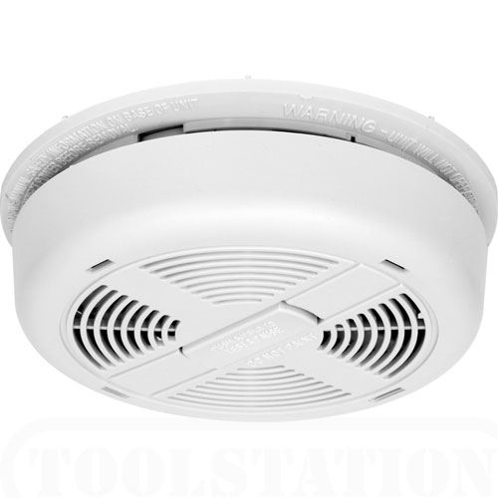](https://www.google.com/url?sa=i&rct=j&q=&esrc=s&source=images&cd=&cad=rja&uact=8&ved=0ahUKEwjK6qX7_onMAhVK52MKHZroBkgQjRwIBw&url=http://www.everydayhomeinspections.com/smoke-detector-safety-tips&psig=AFQjCNFZSgiJUNy4MIgfSM83myeTJIp_CA&ust=1460581128446650)14.

15.