[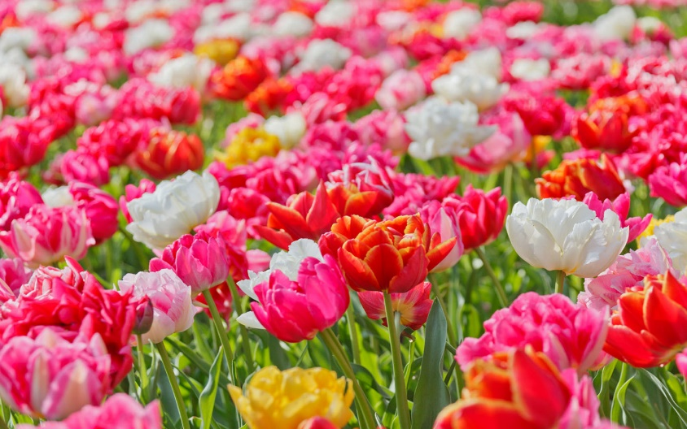](https://www.google.com/url?sa=i&rct=j&q=&esrc=s&source=images&cd=&ved=&url=http://theodysseyonline.com/texas-tech/how-women-are-ruining-feminism/143025&bvm=bv.120551593,d.cGc&psig=AFQjCNHpeEz3BILLkBBUnrqwZ06I8yeKMA&ust=1461704071534263&cad=rjt)My name is Janine. I’m 17 years old, almost 18, and I’m a senior in high school. I plan to go to Washington State University next year. Some of my interests include reading, swimming, listening to music, and watching movies. Watching movies and reading are probably my favorite things to do out of all of my interests. I’m a very positive person and I always have a smile on my face. I also like flowers, and I like them because they always seem to brighten your day.