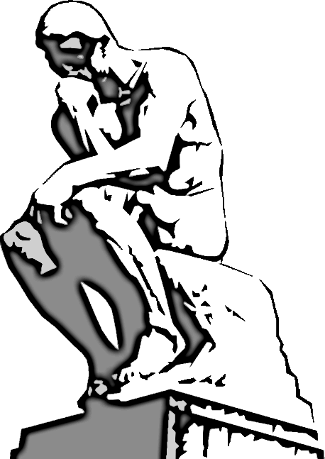

**ACH Knowledge Bowl Team**

**Power!”**

**is**

**“Knowledge**

**“Ridding the World of Ingorance, one match at a time!”**