Get Some!
Get Some!
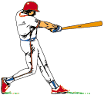
Warrior
Pride!

