

January 11, 2010

To Whom It May Concern:

As Chynna’s teacher for the past four years, I can testify to her ability to work with others, and her commitment to excellence both in and out of the classroom. Chynna is a dedicated worker who is conscientious and thorough in her work.

In the classroom, Chynna is a high achiever who is focused upon her studies and conscientious about her work even while helping others. Many times Chynna has been called to upon to state her opinions and positions in class discussions and she doesn’t hesitate to state her opinion and does so with a good sense of humor. I’ve appreciated her maturity and steadfast commitment to her principles along with her clear, logical thinking. Her focused determination will be a huge asset in attaining her career goals.

Outside of the classroom Chynna has been involved in a number of extra-curricular activities from cheerleading, pep band, to knowledge bowl that reveal her commitment to school and classmates.

Bottom line: her strong commitment to succeed, coupled with a strong desire to learn gives her the tools she will need in college.

I am proud to recommend Chynna Wallin. Her attitude, strong work ethic and academic skills will serve her well in reaching her goals.

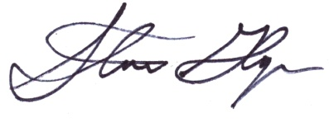Sincerely,

Stuart Gloyn, Teacher

Almira/Coulee-Hartline H.S.

509-632-5231

**413 North 4th Street Coulee City, WA 99115**

**HS 509-632-5231 FAX 509-632-5166**

**www.achsd.org**